AP Screens for Family Works processing:
Check Family Works in the Benefits Information section.
Select Contractor for Family Works under Application Type.
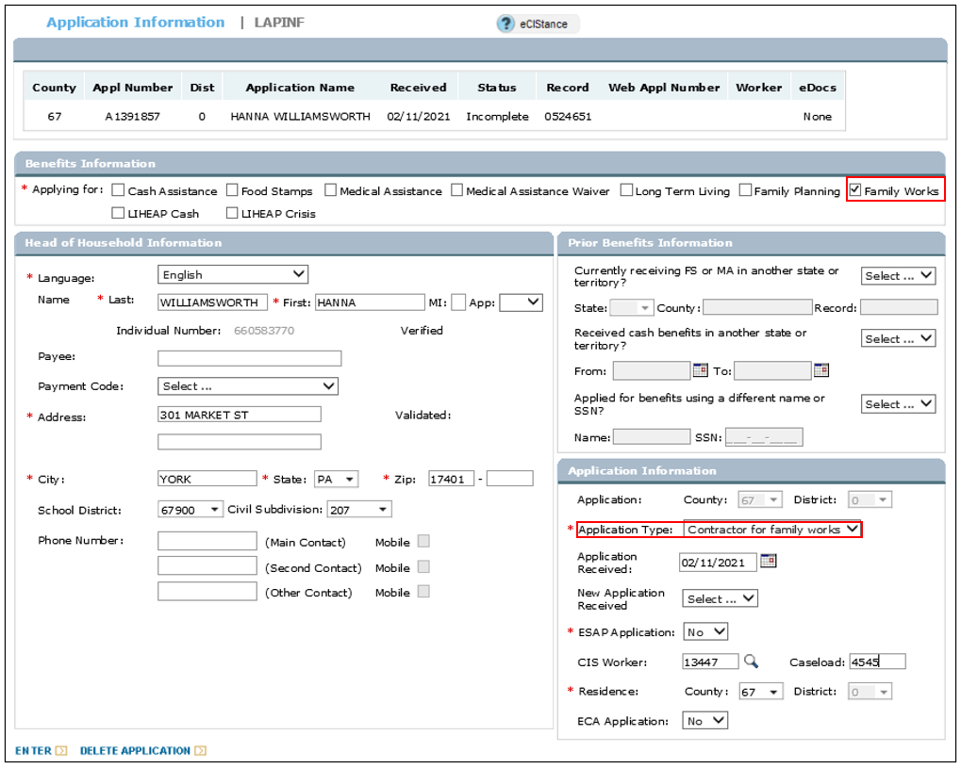

Enter the ELECT Project Code “Y” and Source ID (Project ID found on the Family Works application) in the Family Works Provider section. Click Show Details and select Not Applicable for the Service Type. Click Enter.
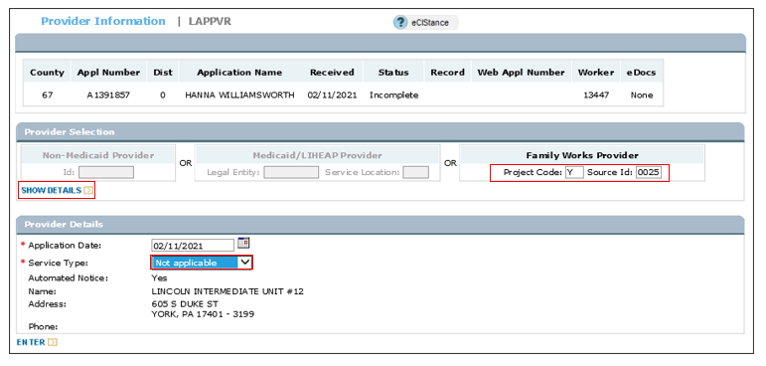
NOTE: If the appropriate ELECT Project ID is not available to request you will receive error “County ID does not exist.” Please submit a Service Now ticket to have it added.
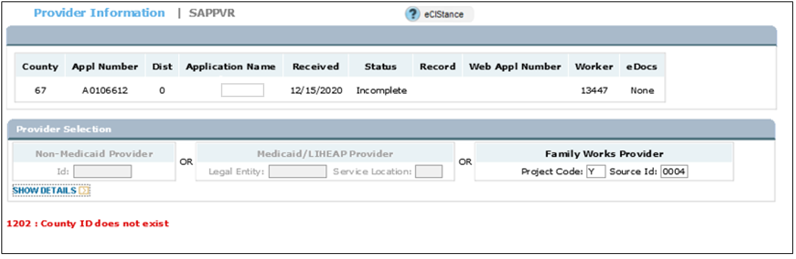

Enter Individual Information for all Household members.
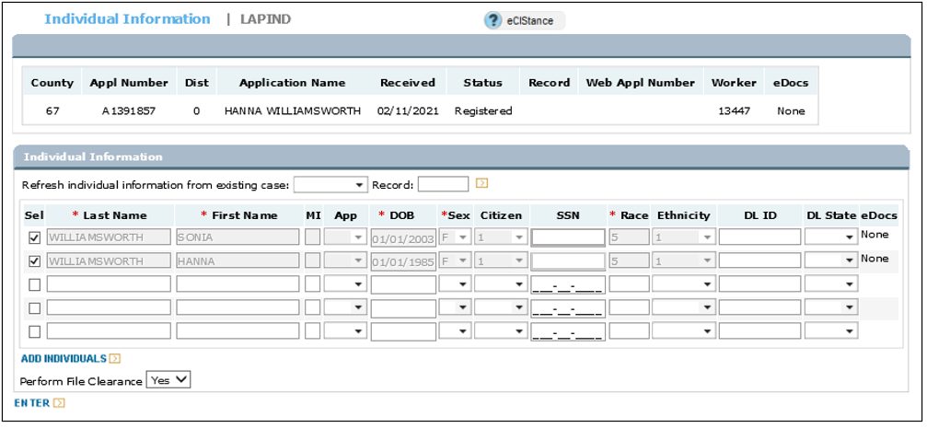
Complete File Clearance.
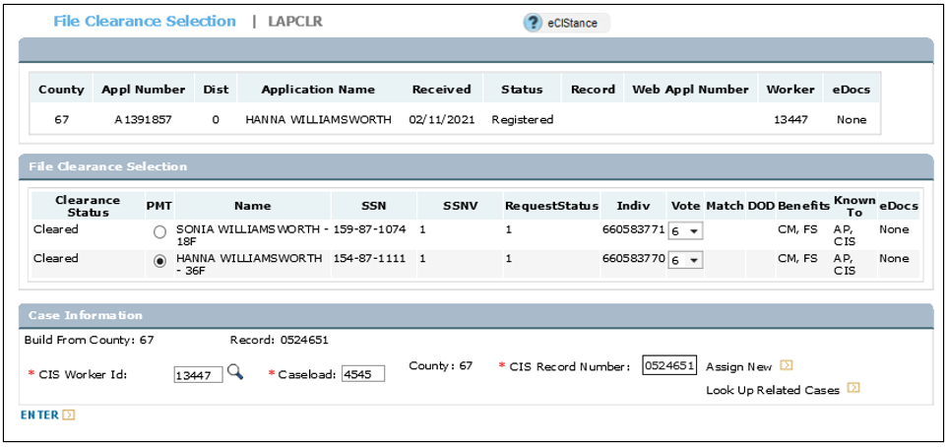
AP screens are complete.

CP Screens for Family Works processing:
Select Case Open or Program Add mode to start processing.
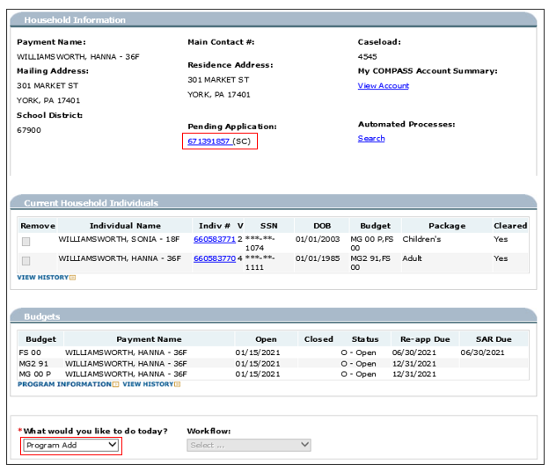
Complete Case Non-Financial /Household screen

On the Program Request Screen, verify SC - Family Works is displaying under Program. Remember to change the Begin Date to match the date on the Family Works application.
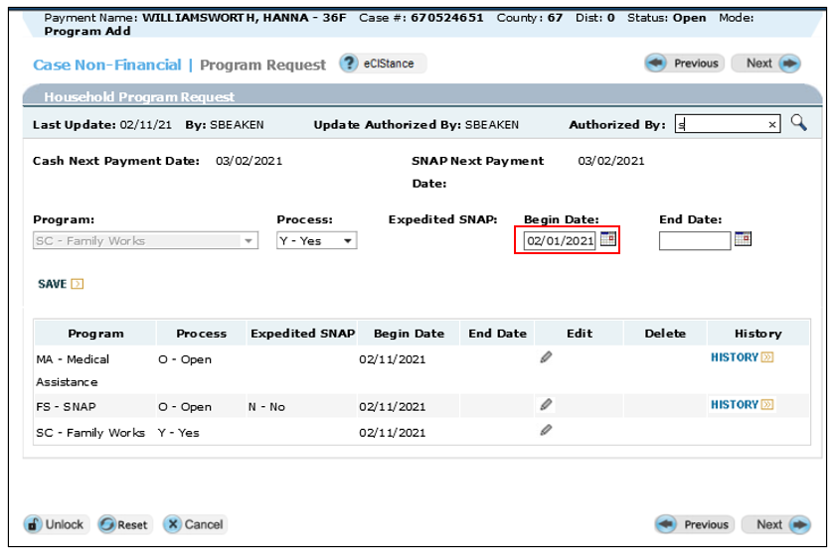

On the Individual Program Request screen, check Family Works for the applicant only. Uncheck Family Works for all other household members.
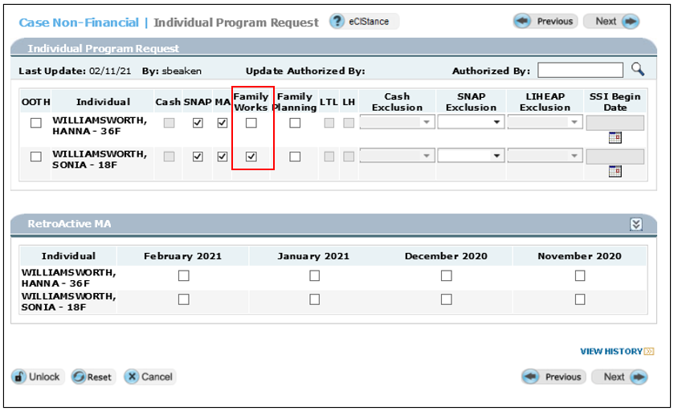
Pass through the following screens:
Case Non-Financial / Program Request Questions
Case Non-Financial / MA Provider
Complete Individual Non-Financial / Demographics
Complete Individual Non-Financial / Tax Information
Complete Individual Non-Financial / Relationships

On the Individual Attributes screen, select ETP for Cash Code 70 – Family Works Participant for the applicant.
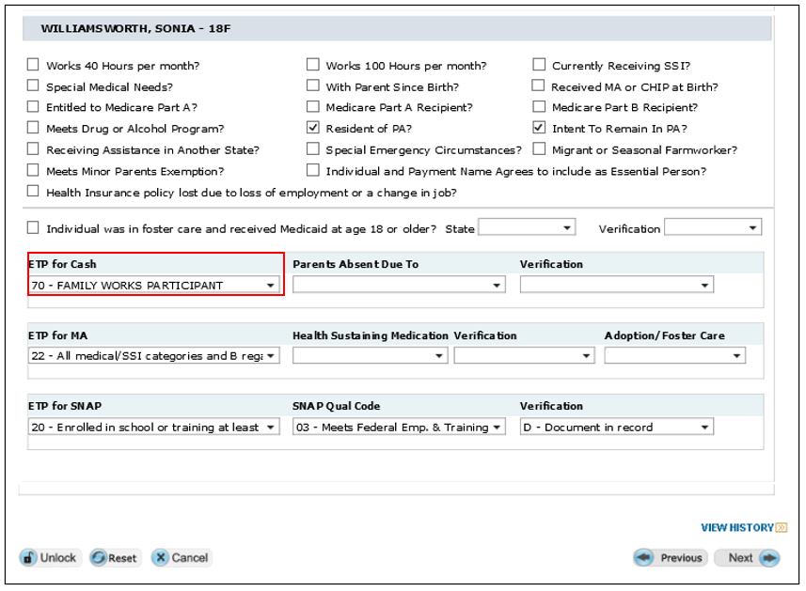
Pass through the following screens:
Complete the Individual Non-Financial Questions – select “Y” for Pregnancy if appropriate
Complete Individual Non-Financial / Pregnancy screen
Complete Individual Non-Financial / School Attendance screen
Pass through Resources / Resources Questions screens
Complete Income / Income Questions screens

On the Family Works Calculation screen, enter student’s income for the gross monthly earned income question. Include the student and his/her dependents in the people in the household question. Click Calculate and the system will provide Pass/Fail result:
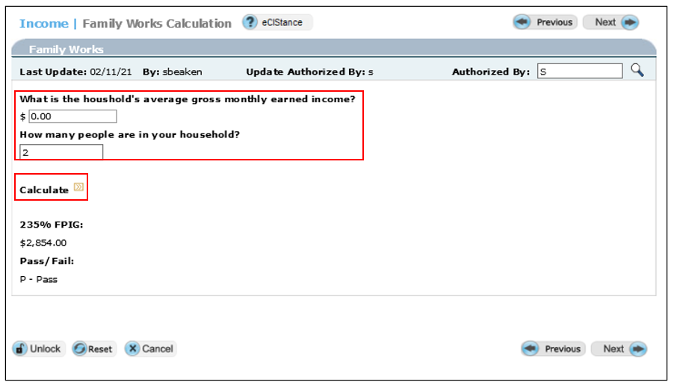
Pass through Expense Questions
Run Eligibility – SC budget will show under the Family Works Eligibility Results Summary.
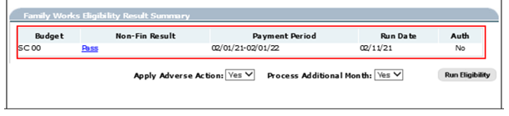

On the ETP Project Enrollment Screen, enter the referral to the correct ELECT program listed on the Family Works application.
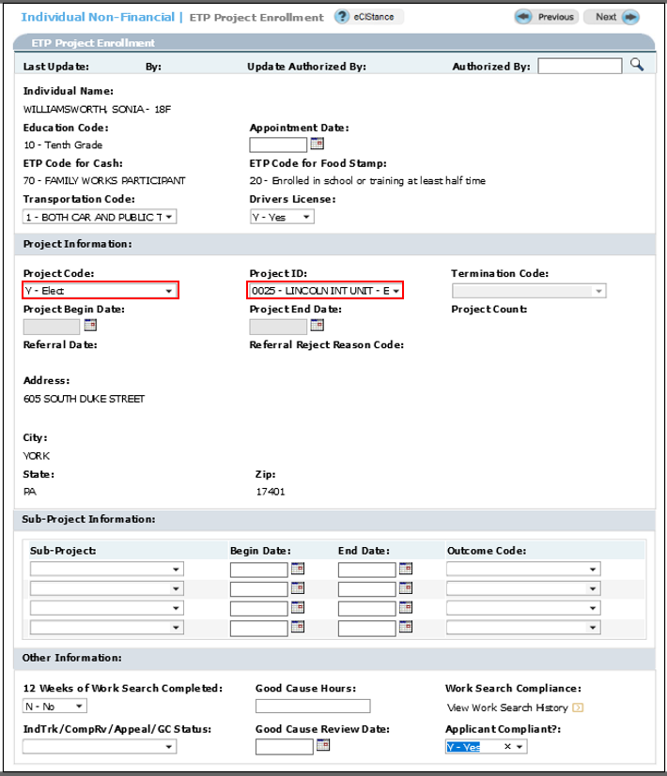

Complete remaining eCIS screens and commit the case. Notice is generated and SC budget is open.
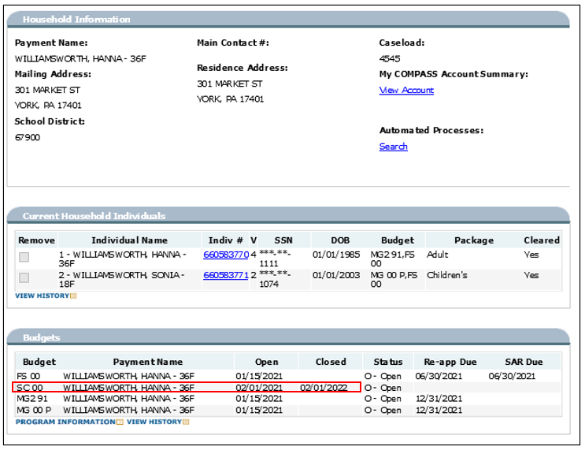
The SC category is a time limited budget. The End Date can be extended in 1 year increments until the student is no longer participating in the ELECT program.
If the ELECT project closing is sent from CWDS prior to the SC closing, Alert 163 will post to notify the worker to close the SC category or change the ETP code to another appropriate code. The alert will clear when the SC category is closed or the ETP Code is changed.

